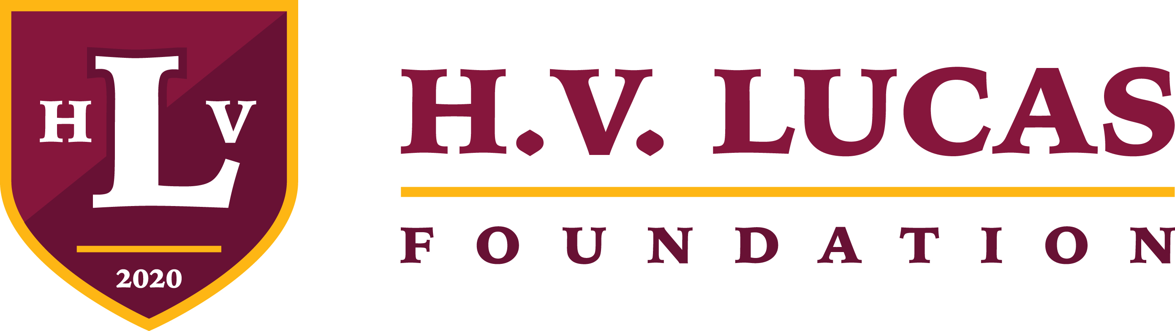
*** 2024 SCHOLARSHIP ANNOUNCEMENT ***

We are pleased to announce that The Harold V. Lucas, Jr. Foundation, Inc. will be awarding a $1000.00 scholarship to six high school seniors in Volusia County. The scholarship recipients will be notified by May 10, 2024. The scholarships will be distributed late-May at an invitation only HVL Foundation Scholarship Awards Event at The Lucas Center in Daytona Beach, Florida.

General Scholarship Criteria for All Scholarships: 1) High School Senior in Volusia County Graduating in Spring 2024, 2) Minority Student and 3) Minimum 3.0 GPA (2.5 GPA for the Citizenship Awards). Two awards will be given in each of the following categories:

HVL Foundation Scholastic Award - The recipients of this award will be students who demonstrate superior academic achievement demonstrated through their grade point average, curriculum rigor, and/or high achievement on state tests or nationally-normed tests or college admission examinations.

HVL Foundation Athletic Award - The recipients of this award will be students who demonstrate superior athletic achievement, good sportsmanship, work ethic, teamwork, discipline, physical and mental toughness, and perseverance.

HVL Foundation Citizenship Award - The recipients of this award will be students who demonstrate that they promote citizenship through having an outstanding attitude and disposition, participation in civic or community activities, volunteer service, school involvement, exemplary character and work ethic.

Required Application Materials:

- One Page Essay - Essay by the student on which award he/she is applying for and why he/she should be the recipient of the award.
- College Acceptance Letter
- Current Transcript
- Teacher Recommendation Letter

Completed application materials must be submitted in PDF format to
admin@hvlucas.org by 5pm EST Wednesday, April 26, 2024.

—————————

The mission of the Harold V. Lucas, Jr. Foundation is to provide support for the historical and cultural development of the Daytona Beach midtown community while continuing the legacy of education, athletics, service, leadership, and philanthropy of Mr. Harold V. Lucas, Jr. For more information visit, hvlucas.org.

