Daytona State College Dual Enrollment Application Steps
visit DaytonaState.edu/Apply and select “Create New Account” to begin
Our application is a simple 2-step process: Step 1 is to create an application account. Step 2 is to sign in with your newly created application account username and password to complete the Dual Enrollment program admissions application.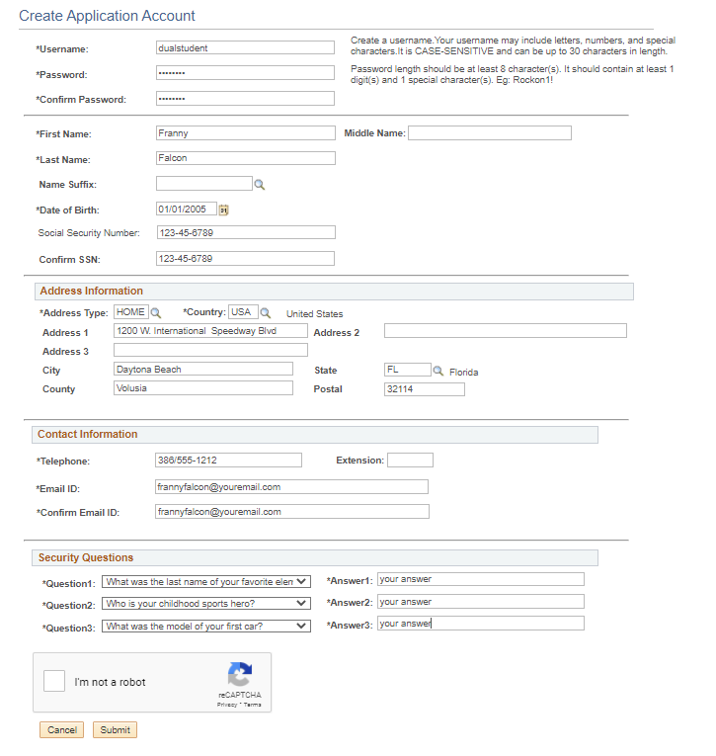
Things to note
- Be sure to capitalize your name & use your full name, not a shortened version (i.e., if your name is Jonathan, don’t use Johnnie)
- A name suffix is an ending like Jr, Sr, or III
After you hit submit, you’ll be directed to log in with your new account information. You will complete each section marked with a red ! until they are all green s, then you can submit your application.
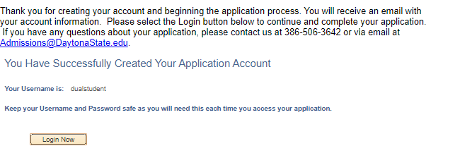
Academic Data Selection
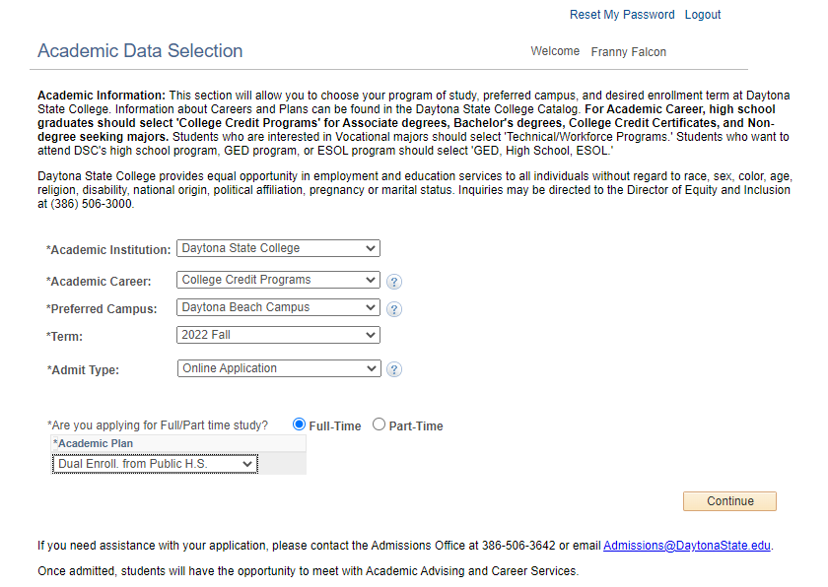
Things to note
- If you are starting in January, select 2024 Spring as the Term
- Your Preferred Campus is the campus closest to you
- Your Academic Plan will either be Dual Enroll from Public HS, Private HS, or Home HS
- Do not select any Academic Plan other than “Dual Enroll from…”
Student Information Section
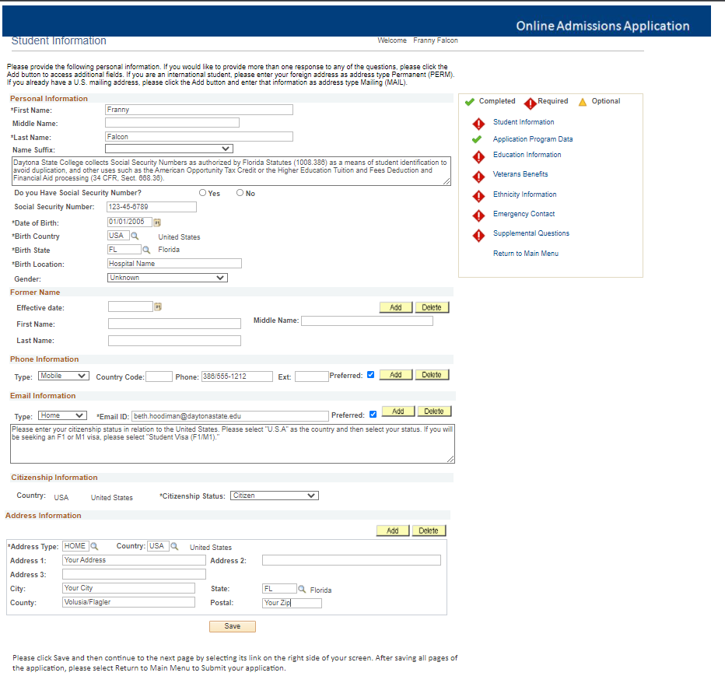
Things to note
- Please select the country and state, and enter the city you were born in for Birth Location
- If you have never changed your name legally, leave the Former Name section blank
- Leave Country Code and Ext blank in the Phone Information section
- For Citizenship Information, do not select Student Visa. Select citizen or permanent resident, whichever applies to you
- Postal means your zip code

Education Information Section
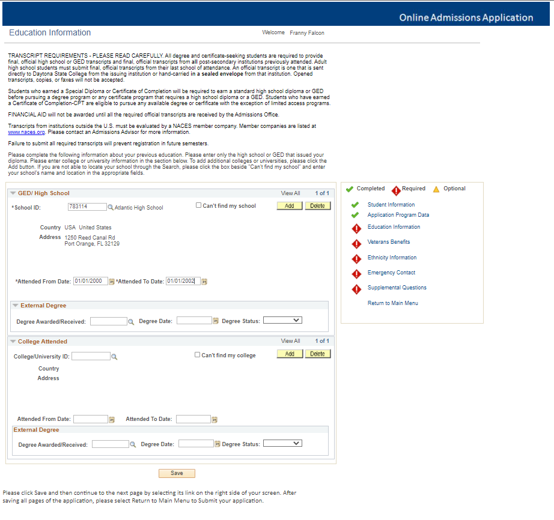
Things to note
- You can find your school code in the chart to the right >
- The Attended From Date should be 08/01/20XX (the year you began high school)
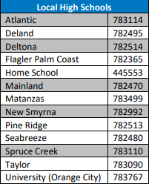
- The Attended To Date should be 05/31/20XX (the year you will graduate high school)
- You may leave all other sections (External Degree & College Attended) blank

Veterans Benefits & Ethnicity Information Sections
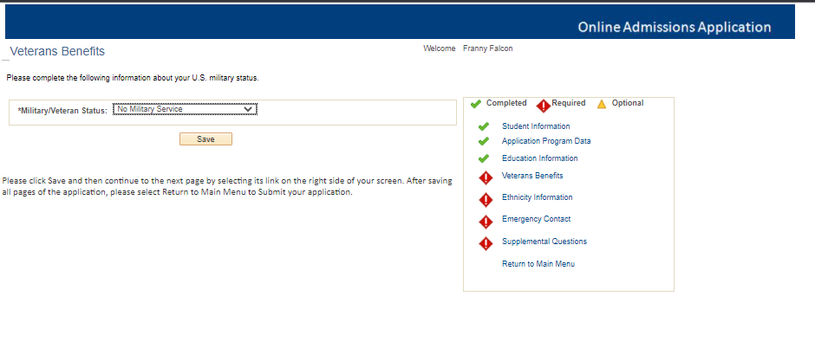
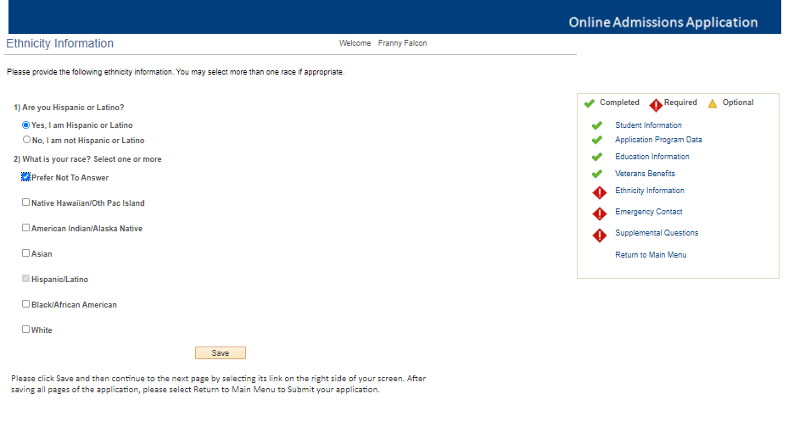

Things to note
- If you have never served in the US Military, select No Military Service

Emergency Contact Information
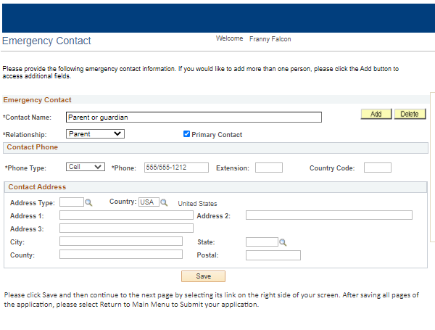
Things to note
- Make sure all the information on this page is your emergency contact’s information not your own
- Leave Country Code blank
- Postal is the zip code
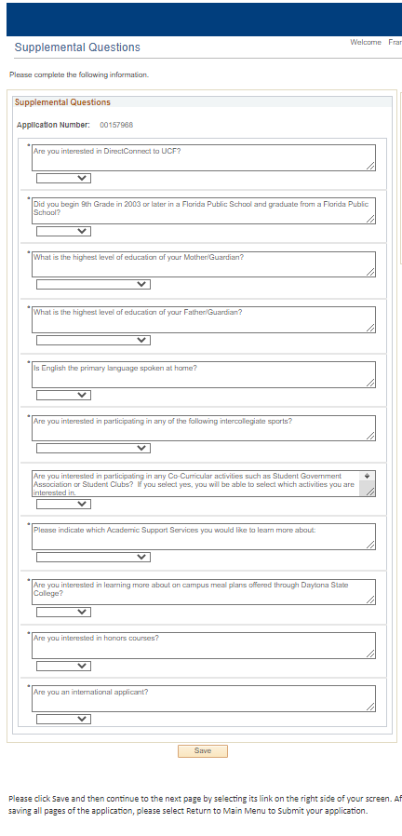
Things to note
- Direct Connect to UCF allows you to continue to UCF for your bachelor’s after DSC
Now that all sections have green s, you can submit your application. Click “Yes, I Accept” and hit Submit to finalize the application – Welcome to Daytona State College!!
