Dual Enrollment Process

A) Read the Dual Enrollment Guide (Pay close attention on pages: 2, 5, 6, and 7).
https://www.daytonastate.edu/dual-enrollment/files/dual-enrollment-guide.pdf
B) Apply online ✅
www.DaytonaState.edu
(From the menu: New Student Resource>> Apply Now)
Step 1-Create an account!!!!
Step 2-Log in with that username and password you created.
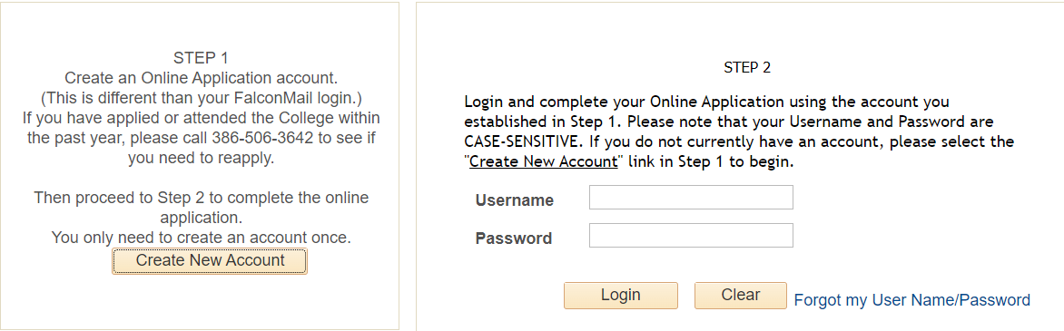
Click here to see the steps to complete the application!!!
*Don’t forget this information-*
Choose College Credit for Academic Program.
Choose Dual Enrollment from Public High School
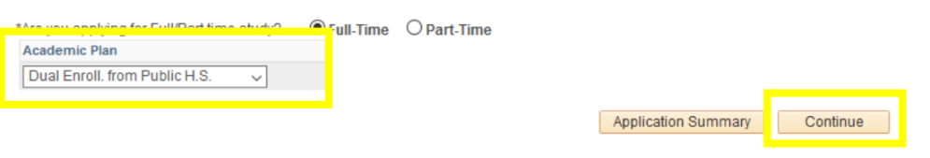

SCHS code is 783110
*After all the check marks are green, you will click on the green submit button …
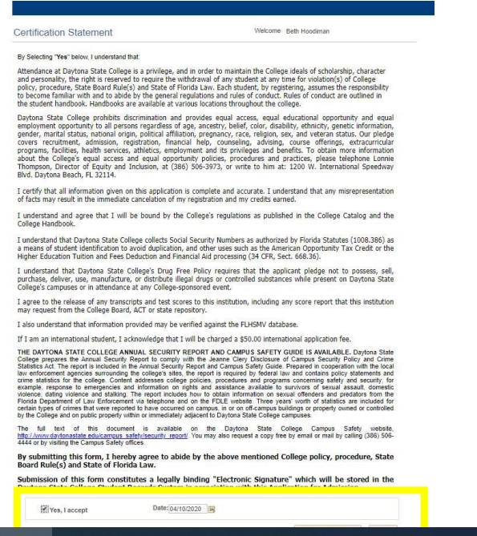
*Click Yes and submit on the next page that will come up
C) Activate your DSC student portal with the DSC e-mail that you received in your admissions acceptance letter and e-mail.
*1-Go to Daytonastate.edu >Menu >For students >MyDaytonaState.
*2-Click on the Falcon Self-Service (for the first time)
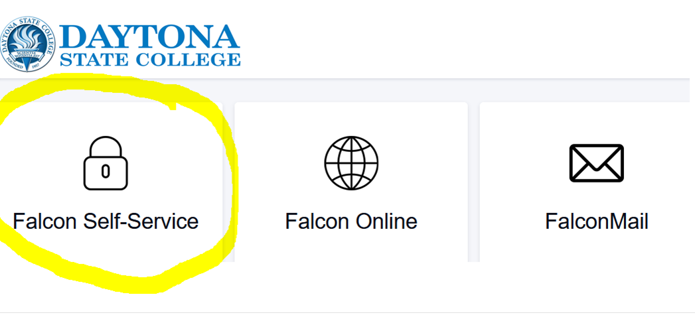
*3- Add your new e-mail address:
first name__last name@Daytonastate.edu
Example: mario_smith@Daytonastate.edu
*4-The first time your default password is going to be:
DSC (two digits for your birth month, two digits for your birthday and two digits for the year you were born and the last five numbers of your social security number)
Example: Dsc09190312345
*5- Once you have logged in, you will be prompted to create a new password.
**Make sure you have 12 letters and number and one symbol. It can’t be your first/last name, social security number, or birthday
**Example: Youlikethehawks2022!**
**If you have any questions, please contact the DSC IT Help Desk:
386-506-3950 or helpdesk@daytonastate.edu**

D) Once you have received your admissions acceptance letter and e-mail, book an appointment to see Mr. Schafer to complete the Dual Enrollment Check List 😎
Book an appointment here-
https://outlook.office365.com/owa/calendar/SpruceCreekHighSchoolCollegeandCareer@VolusiaStudents.onmicrosoft.com/bookings/

Student: _______________________Grade:__________Alpha:________

DUAL ENROLLMENT CHECKLIST

___ A) The student read the Dual Enrollment Guide

___B) The student applied online at DSC. ID number: ____________

___C) The student activated Falcon e-mail

___D) The student met with Mr. Schafer and is ready to send the Dual Enrollment Form to DualEnrollment@DaytonaState.edu

Questions or Concerns:

