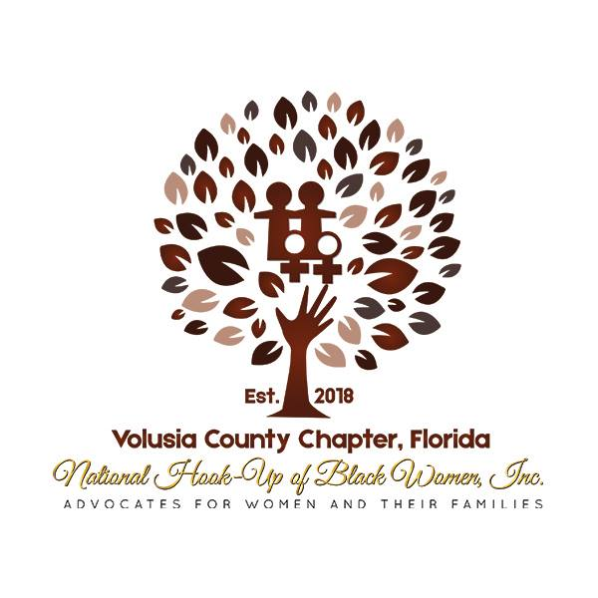

Greetings High School Seniors,

The National Hook-Up of Black Women (NHBW) Inc. is a non-profit 501c3 organization founded in 1974; and the Volusia County Chapter was established in September 2018. NHBW works to improve the quality of life, facilitate preservation, achieve self-empowerment, and promote economic development.
The Volusia County Chapter will award $1,100 to a graduating high school senior who has demonstrated academic excellence and service to their community. Completed applications are due electronically by April 1, 2024.

Click on the link below to access the scholarship application.
NHBW Volusia County Chapter Scholarship for High School Seniors 2024

Sincerely,
Francene Barnes, Scholarship Committee Chair
(386) 290-7562
Brittany Louis, 1st Vice President
(561) 310-0159
Gina L. Fountain, President
(386) 451-2665

